# Daily Notification Emails

## MAV Retrieve profile:

The MAVs that are due today will be identified by the current request year: <<@RESD-AYRC SLP>>, the mod codes supplied by: <<@RESD-DUETODAY>> and will be limited to occurrences of A - M (to account for resits).

## @RESD-DUETODAY:

blank<<MAD_DDATE=<$DATE>&G@RESD-DUETODAYMODCODE>>

The SLP RESD-DUETODAYMODCODE returns:

[MAD.CAMS:·|<<MOD_CODE.MAD>>]

This will result in a gold Bar separated list of mod codes with due dates today. It will have a leading entry of blank to prevent any *all retrieves and also to ensure there is never a trailing delimiter.

## Retrieved MAVs

The retrieve profile above will be used to bring back more MAVs than are actually valid (though still a lot less than any other method). We will reduce these as we go.

The retrieve profile is:

<<MOD_CODE=<@RESD-DUETODAY>·;AYR_CODE=<@RESD-AYRC>·;PRS_CODE=·*·;MAV_OCCUR=A·|B·|C·|D·|E·|F·|G·|H·|I·|J·|K·|L·|M&G…

We now need to run MAV letters to send an email to the prs_code for each returned mav. If there are no requests for a mav, the letter contents will be blank and no email will be sent.

When searching for requests, we also need to check for the corresponding re-sit (A = Z, B = Y etc.) we will use XON later for this.

## MAV-MAD

There is no standard letter group for MAD so we will use the 4 field primary key from MAV to go to a MAD SLP.

The mad slp will be retrieved on:

<<MOD_CODE=<MOD_CODE.MAV>·;MAV_OCCUR=<MAV_OCCUR.MAV>·;AYR_CODE=<AYR_CODE.MAV>·;PSL_CODE=<PSL_CODE.MAV>·;FORCEALLFIELDS=Y&G@RESD-NOTIFY>>

## MAD SLP

This is where we'll link to the OBRs and bring back their details (if there are any)

We will retrieve a list of OBRs which meet the profile populated by the MAD. We also need to perform a search on the OBR Text field as it is not part of the OBR primary key and so will not be checked by the SRL syntax - this is important for mav occurrence checking.

We will also need to repeat the search with the re-sit occurrence - using XON to replace.

[MAD.CAMS:<<OBR_OBJC=ER-·*·;OBR_OBIC=1·;OBR_CODE=<MAP_CODE.MAD>~<MAB_SEQ.MAD>·;OBR_IUSE=Y·;OBR_SFTR=<&$DATE&DD2/M3/Y>·;OBR_UDF1=1·*·;SEARCH=<MOD_CODE.MAD>~<PSL_CODE.MAD>~<MAV_OCCUR.MAD>·;FORCEALLFIELDS=Y&G@RESD-NOTIFY-CONTENT>><<OBR_OBJC=ER-·*·;OBR_OBIC=1·;OBR_CODE=<MAP_CODE.MAD>~<MAB_SEQ.MAD>·;OBR_IUSE=Y·;OBR_SFTR=<&$DATE&DD2/M3/Y>·;OBR_UDF1=1·*·;SEARCH=<MOD_CODE.MAD>~<PSL_CODE.MAD>~<MAV_OCCUR.MAD&X[OCCURRENCE]>·;FORCEALLFIELDS=Y&G@RESD-NOTIFY-CONTENT>>]

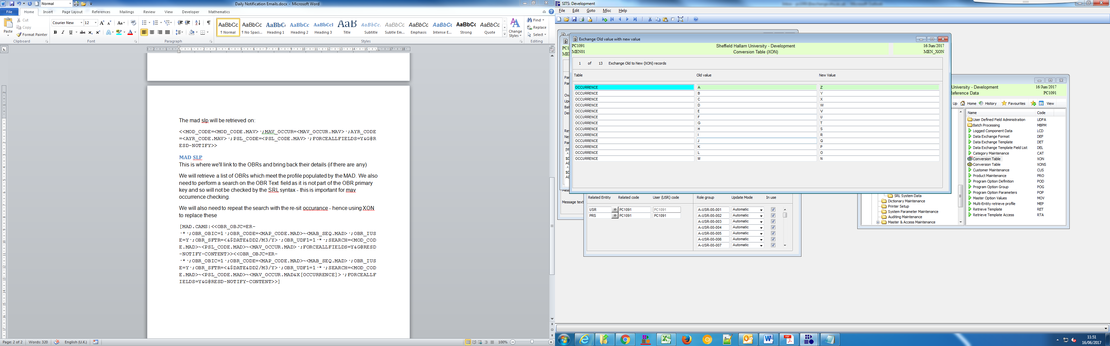

Once this is complete, we can return whatever values we want in the SLP RESD-NOTIFY-CONTENT

[OBR.MENSYS:<<OBJ_PRFL.OBJ&EF(/)&GSTU_NAME.STU.SRS>> has been granted an extension on assessment "<<OBR_NAME.OBR>>" until: <<OBR_SFTR>>

]

## Setting up the job

Now we need to set up a batch letter job to run this every night.

Using the same SLPs as in the first step of this document, set up the BSL retrieval values:

